# POSITION PAPER BY THE SENIOR SPECIAL ASSISTANT TO THE PRESIDENT AND NATIONAL CO-ORDINATOR SERVICOM, MR. SYLBRIKS OBRIKI AT THE PUBLIC SERVICE REFORM RETREAT HELD ON THURSDAY, 22nd JANUARY, 2015

Protocol

I am pleased to be at this event which marks another critical step in the latest attempt to appraise Government’s reform initiatives and chart the future direction of public service reforms, while bearing in mind that actualizing overall improvements in the quality of public goods and services to citizens is the overall goal of all reforms.

SERVICOM’s role as the Service Delivery office of the nation remains to work with MDAs to be more citizen focused while ensuring that all citizens are served right at all Government service points.

However, I will like to reflect on the role of SERVICOM in this regard by providing a snapshot of SERVICOM’s past and present contributions towards improving public service delivery – as well as project a future for SERVICOM based on a number of present realities and assumptions in relation to other existing initiatives of Government.

**SERVICOM - Background**

SERVICOM represents the Service Compact between the Federal Government and citizens. It is backed by several administrative instruments of Government, including service-wide circulars and Federal Executive Council Resolutions aimed at establishing its oversight function within MDAs via a network of Nodal Officers in Ministerial SERVICOM Units (MSUs).

SERVICOM was conceived as both a Govt-2-Govt monitor of performance, as well as the Govt-2-Citizen agent, that manages the performance-expectation gap between Government and citizens in issues of service delivery. This is to evaluate the quality of services delivered to citizens in the realisation of the essence of governance, while reporting its findings to the Federal Executive Council through the Office of the Secretary to the Government of the Federation (OSGF).

**Phases of SERVICOM reform actions:**

1. The key elements of the SERVICOM roadmap under the first phase were to instil higher expectations of public services amongst Nigerians, to change Nigerians experience of public service delivery, build wider support for service delivery, demonstrate Ministers’ leadership as MSUs reported Service Delivery issues through permanent Secretaries in their departments, and radically change the existing managerial systems. This phase operated under a sponsorship agreement with the UK Government, administered by DFID and counterpart funding by the federal Government. This phase ended in September 2009 after a nine-month extension following the initial December 2008 end date. Assessment by the British review team rated SERVICOM as a high performing development aid programme.
2. The second phase commenced with Government’s commitment to continue sponsorship of the service delivery initiative. The activities implemented in this phase were: an expansion of its operations, an increase in the number of SERVICOM compliance evaluations, an increase in scope of actions in handling public complaints on service failures, an intensification in public awareness campaigns, a building on the current experience and knowledge to design, and an execution of service delivery improvement modules as a follow up to the already executed pilots so as to accelerate the dissemination and propagation of the real SERVICOM experience. This commitment was not met fully given the low funding by Government, thereby resulting in a decline in the activities of SERVICOM.
3. The third phase commenced with the repositioning of the programme under the Government’s Transformation Agenda. In February 2012 a paper on ‘The Future of Service Delivery in Nigeria’ was presented to the Federal Executive Council (FEC). Some of the key recommendations of a nine-member Cabinet Committee chaired by the Secretary to the Government of the Federation constituted 29 February 2012 to look into ways of revitalising the SERVICOM Office to make it functional and explore a suitable funding mechanism for its operations include:
   * 1. The relevance of SERVICOM has become imperative in today’s governance
     2. Ministers should own SERVICOM and be conscious of their responsibility to it by reaffirming their compact
     3. The approval of a bridging fund for SERVICOM operations was suggested
     4. Each MDA should make a budgetary provision for its Ministerial SERVICOM Unit (MSU) to fund its management approved work plan.

**SERVICOM – Current Realities**

The impetus granted by the 2012 FEC Circular enabled the SERVICOM Office to secure its Office within the Federal Secretariat and resume operations geared towards achieving its renewed mandate, and with support from the UK–Aid Federal Public Administration Reform Programme (FEPAR) developed its new Strategic Plan and Objectives for the period between 2013 and 2015 as follows:

SERVICOM’s key priorities from 2013 to 2015 are to:

1. Develop and implement service charters
2. Raise citizens’ satisfaction
3. Increase citizen’s awareness
4. Develop robust performance monitoring and reporting systems
5. Ensure its own sustainability

**SERVICOM’s strategic objectives were to achieve the following by 2015:**

1. Increase the number of ministries (and comprising parastatals) with and implementing qualitative Service Charters
2. Raise the proportion of citizens satisfied with public sector service delivery by reducing the incidence of service and empowered to challenge service failures
3. Achieve long-term survival and sustainability through improved funding, capacity building, and enhanced partnership with stakeholders.

**Review and Pilots of SERVICOM Tools (2012-2014)**

**Service Charter Development**

The service charter is a public statement about the services an organisation is providing; a commitment made to stakeholders by an organisation about the services they should expect to receive, how to receive it and what to do when services fail.

At the inception of SERVICOM in 2003, MDAs were directed by the Federal Executive Council to draw up their service charters using a Service Charter checklist provided by the SERVICOM Office. SERVICOM from then has guided all MDAs to develop, publish and implement their Service Charters. This evolution to customer rights and quality service delivery in Nigeria has recorded relative success**.**

**National Service Charter Guidelines**

The guideline is a more robust document to guide all service providers, especially MDAs to use key elements/components contained therein to facilitate the provision of service in strict compliance with service standards of MDAs. With the application of the Service Charter checklist in MDAs for about 9 years it became necessary to review this tool given the slow response and gaps observed in the process of implementation in MDAs.

A National Guide for Developing and Implementing Service Charters which includes guidance to MDAs on setting service standards and ensuring stakeholder input was produced in 2014 to assist MDAs achieve consistency in the Service Charter development and implementation process.

This development of qualitative Service Charters was envisaged to be the demonstration of MDAs readiness to serve citizens, based on agreed standards of performance which hitherto was lacking in most MDAs. The lack of a consistent approach to development of service charters, and lacklustre implementation of existing service charters in MDAs had made it incredibly difficult to assess and/ report service delivery performance and citizen satisfaction in the past.

This situation highlighted above had devalued the SERVICOM Compliance Evaluation Reports arising from the Evaluation of selected MDAs service windows – even though thesehave remained the main tools for generating Service Improvement Plans. These reports are discussed and presented to the management of evaluated service windows in MDAs with the aim of ensuring implementation and has been met with mixed reactions in MDAs.

**The SERVICOM Index**

The key tool used by SERVICOM in the conduct of these Evaluations and service delivery assessments is the **SERVICOM Index**; the index is a yardstick for measuring the quality of services delivered by Government through its MDAs with the overall consideration of citizen satisfaction for service delivery. The SERVICOM Index was first adopted by the Federal Executive Council on June 8, 2005 and has been in use to evaluate the services of MDAs for about 9 years and reviewed in year 2013.

The review of the SERVICOM Evaluation Index was premised on the need to refocus the instrument towards a more citizen-centric approach adopted after an initial perception survey carried out in 2013. Results from the survey indicated that there was a general lack of understanding among citizens about their role in service delivery, and SERVCOM’s mandate in increasing citizen awareness and participation in improving service delivery outcomes.

This findings informed SERVICOM’s new approach towards strengthening citizen participation was conceived as SERVICOM’s means of switching from the ‘long route’ to the ‘short route’ of the social accountability system[1].Figure 1.1 below highlights this relationship and the SERVICOM message is being revised from the previous compliance emphasis, to a more “facilitator” and enabler role.

**Fig. 1.1 - Key Actors for Implementing Social Accountability[2]**

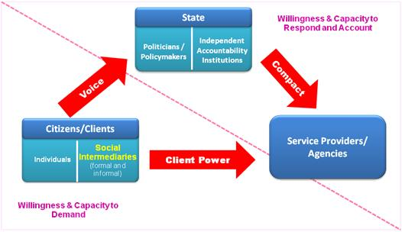

A second important reason for reviewing the SERVICOM Evaluation Index was to align SERVICOM with the stated objectives of Government in transforming the civil service into a more efficient, modern organisation. Specific activities in Pillars 1 & 2 of the National Strategy on Public Service Reforms were noted as having direct bearing on the mandates of SERVICOM, especially with regards to Government’s commitment to providing an ‘*enabling institutional and governance environment for public service institutions to deliver public goods and services in accordance with their mandates, and with integrity, transparency and accountability’[3]*.

The third reason that necessitated a revision of the old SERVICOM Evaluation Index was the evident slow pace of adoption of a service improvement culture within the public service. SERVICOM Office had noted that after almost ten (10) years of the Service Delivery Initiative, there was a need to include more business-relevant key performance indicators in its measurement tools in line with global best practice and current trends in public service delivery.

The new SERVICOM Index was therefore designed to measure the performance of service windows of an MDA against six dimensions which are weighted according to their importance in the implementation of MDA Service Charter as a social contract between Government agencies and citizens. These dimensions are Policy Commitment (10%), Service Delivery (25%), The Customer (20%), Organizational Effectiveness (20%), Accountability (15%) and Innovation (10%).

Fig. 1.2 **- The Old SERVICOM Evaluation Index**

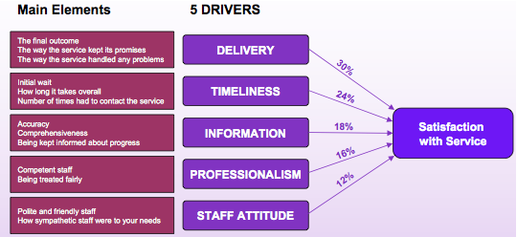

**Fig. 1.3 - The Revised (new) SERVICOM Evaluation Index**

|  |  |  |  |  |  |
| --- | --- | --- | --- | --- | --- |
| The Vision |  | Customer Satisfaction | | | |
|  |
| The Pillars |  | Service Delivery | Organizational Effectiveness | Accountability | Innovation |
|  |
|  |
| The foundation |  | Policy Commitment | | | |
|  |

The introduction of the new SERVICOM Evaluation Index and subsequent pilots in ten (10) MDA service windows in 2014 have begun a shift in the Evaluation Index’s focus, from the old purely performance evaluation matrix, to a more encompassing instrument that measures the whole framework of service delivery.

Ensuring a harmonised, consistent approach for all MDAs to engage citizens in the service delivery contract will enable SERVICOM to monitor progress towards implementing the standards of performance stated in the service charters and subsequently use the revised Evaluation Index to reward objectively verifiable success in service delivery improvement efforts by MDAs.

This focus on more citizens’ engagement has underpinned SERVICOM’s new focus on stimulating citizen demand for services as a right. It is envisaged that by enhancing the roles of all critical stakeholders in the service delivery framework, SERVICOM can be repositioned for better effectiveness.

**SERVICOM - Main Achievements**

Some notable achievements of SERVICOM include:

1. SERVICOM has initiated the establishment of Ministerial SERVICOM Units (MSUs) and Parastatal SERVICOM units in 84 ministries, parastatals, and agencies
2. From inception to date, SERVICOM has supported the development of qualitative service charters in over 80% of MDAs with citizen-facing service windows. These now have mission/vision statements that include citizen expectations for services.
3. The establishment of the SERVICOM Institute responsible for the training of public servants in service delivery. To date, over 10000 civil servants have been trained in various aspects of service delivery by the institute and this continues to be the service-wide capacity building arm of the Service Delivery Initiative.
4. The development and publication of the National Guidelines on Service Charters. This is expected to enable MDAs implement service standards as captured in their service charters. This also puts citizens at the heart of all service delivery and improvement efforts in MDAs.
5. The revision of the SERVICOM Index was undertaken in 2012 to include key dimensions of the service delivery framework. The five dimensions for evaluating citizen satisfaction and service delivery from the old Index were expanded to include a sixth dimension incorporating the political commitment and accountability on the part of Government to respond to citizen demands for service.This new tool has undergone trials with key MDA’s such as the NDDC and FCTA in 2013/14.
6. The establishment of complaints mechanism in all MDAs. This is to ensure regular feedback on quality of services from citizens and to redress incidences of service failure when they occur in order to improve MDAs customer service.
7. SERVICOM Compliance Evaluations have been conducted in 202 service windows in 24 MDAs. Service windows being departments/units of Government that has interface with the public.
8. The existence of SERVICOM in MDAs has created awareness of the importance of service delivery principles to both citizens and public servants.

**Key Challenges**

1. The lack of guaranteed continuous funding had stifled the growth of the reform. It is dependent on the favourable disposition of the Government in power and donor support for continuous funding. This was evident in its second phase. The limitations of this were evident in its second phase and still lingers in this current phase.
2. Commitment of political leadership is critical to its success. Its sustainability depends on several factors that require top leadership commitment.
3. SERVICOM’s composition appears to lack adequate numbers of senior level civil servants with capacity required to drive public service wide strategic change management initiatives.
4. Public office holders and senior civil servants are yet to be held accountable for their MDAs’ level of service delivery.
5. With weak information systems, it is hard to assess the shift in quantity and quality of service delivery in most contact centres.
6. SERVICOM is perceived as ineffective and lacking in most quarters, therefore, it is unable to amass the momentum required to create an effective service delivery culture in MDAs.
7. Having SERVICOM Nodal officers reporting directly to ministers has met with mixed reactions in MDAs. While it has been successful in some MDAs such as FIRS, FRSC, NTA and some tertiary health institutions, it has however been stifled in many MDAs, given the culture of the public service.
8. Reduced activities from the second phase to date on key SERVICOM activities, due to lack of funding and political commitment to the service delivery initiative.

**SERVICOM – Future Plans**

* **The Citizen Mark Scheme & Awards**

The introduction and launching of the **Citizen Mark** as an award of service delivery excellence for which MDAs can be recognised. This is a new innovation that SERVICOM is currently working on in view of the need to encourage healthy competition among MDAs.

Although there will be an ongoing requirement for independent assessment of service provision and quality which features a strong compliance element, the SERVICOM Office is also keen to introduce, in parallel, a **Citizen Mark** scheme which supports and encourages MDAs to apply for accreditation. To ensure consistency with existing approaches for reviewing the quality of MDA services it is intended that the accreditation assessment process will utilise the SERVICOM Index as its core tool.

The assessment criteria, while based on the Evaluation Index is comprised of five elements: setting standards and performing well; consulting customers, partners and staff; accessibility and choice; continuous improvement; and use of resources.

The scheme will also be used to encourage constructive and open competition amongst MDAs and provide a vehicle for celebrating success and sharing good practice.

An assessment framework and scoring guide for achieving the Citizen Mark has already been developed and is set for pilots in 2015. Full descriptions of the award has been presented to the SGF and also to a select group of MDAs in December 2014. The modalities for assessment and awards are currently online on the SERVICOM website.

**Fig. 1.4 – The CitizenMark Scheme[4]**

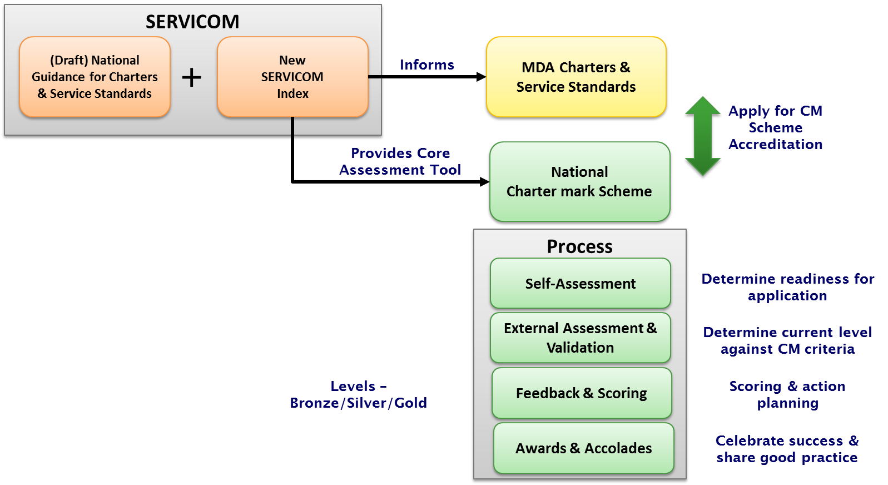

* Integrating **SERVICOM Evaluations/Assessments** (service delivery assessments) in MDAs Performance Management system.

In view of the robust nature of the revised Index with its encompassing focus/dimensions which have clear linkages to the objectives of the National Strategy on Public Service Reforms, SERVICOM Office intends to propose a service delivery assessment framework to the Steering Committee on Reforms for consideration as part of the National Performance Management System.

This is borne out of the belief that sustainable improvements in service delivery in the public sector can only be achieved when MDAs service delivery assessment/Evaluation results are embedded into both organisational and individual performance measures.

SERVICOM Office is concerned that without clear institutional linkages between individual performance in service delivery at the MDA level and organisational goals, it is highly unlikely that the culture of service can be sustained within the public sector. A situation where individual staff schedules do not include service delivery competency measures leaves a lacuna in holding MDAs staff accountable when service failure persists.

We believe that the future of the service delivery initiative hinges the development of a set of well-defined service delivery performance management metrics, for which service providers (including individual staff) are obligated to deliver and rewarded for higher levels of citizen satisfaction with government services. This is a proven incentive for engendering higher levels of service delivery.

A representation of the proposed framework is presented below and its essence is to institutionalise service delivery as a core function of performance in MDAs.

**Figure 1.5 – SERVICOM & Performance Management in MDAs**

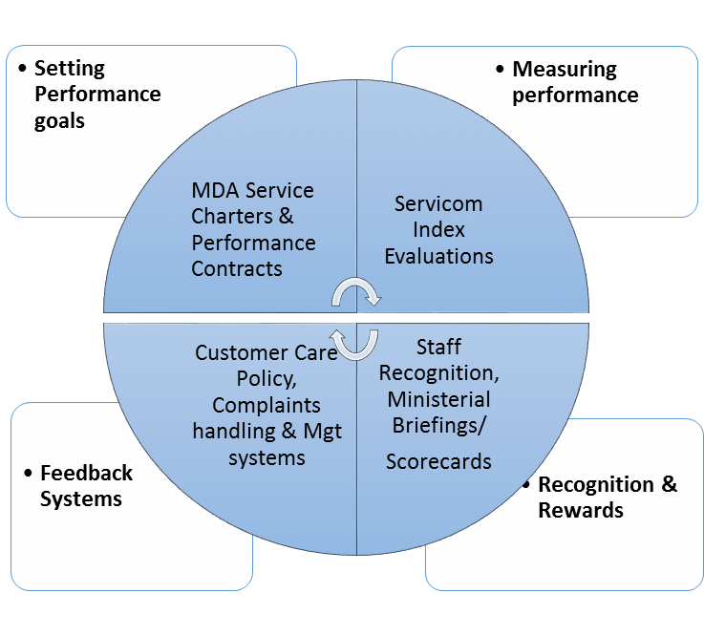

Experience from other countries indicate and affirms SERVICOM’s belief that in order to reinforce the service delivery initiative, there has to be more incentives for public servants in addition to citizen participation/demand.[5][6]

SERVICOM’s citizen-facing role in educating citizens about right to service remains a critical feedback mechanism for performance management in MDAs, and by building effective coalitions as part of the social accountability framework, SERVICOM can remain an essential component of service delivery and performance improvement.

Finally, I like to conclude by reiterating that SERVICOM must be seen as the citizen-facing arm of all Reforms and strengthened to overcome its challenges.

Thank you for your attention.

Mr. Sylbriks Obriki

SSAP/National Coordinator

January 2015

1. Bukenya, B., & King, S. (2012). The contextual factors that shape social accountability.
2. WorldBank - https://saeguide.worldbank.org/what-social-accountability
3. National Strategy on Public Service Reforms
4. SERVICOM Office (2014) A CitizenMark Award for Nigeria
5. Odugbemi, S., & Lee, T. (Eds.). (2011). *Accountability through public opinion: from inertia to public action*. World Bank Publications.
6. [DFGG Companion Piece to GAC Phase 2 Strategy: Strenghtening the World Bank’s Engagement on Demand for Good Governance (DFGG)](http://siteresources.worldbank.org/EXTSOCIALDEVELOPMENT/Resources/244362-1193949504055/4348035-1352736698664/8931746-1364579999657/DFGGCompanionPiece.pdf), Social Development Department, World Bank, 2012. [pdf]